wVISVESVARAYA TECHNOLOGICAL UNIVERSITY
“JnanaSangama”, Belgaum -590014, Karnataka.


LAB REPORT

On
ANALYSIS AND DESIGN OF ALGORITHMS (23CS4PCADA)

Submitted by

LIKITH KRISHNAN (1WA24CS155

in partial fulfillment for the award of the degree of BACHELOR OF ENGINEERING
in
COMPUTER SCIENCE AND ENGINEERING


B.M.S. COLLEGE OF ENGINEERING
(Autonomous Institution under VTU) BENGALURU-560019
February to June 2026

CERTIFICATE
B. M. S. College of Engineering,
Bull Temple Road, Bangalore 560019
(Affiliated To Visvesvaraya Technological University, Belgaum) Department of Computer Science and Engineering



This is to certify that the Lab work entitled “ANALYSIS AND DESIGN OF ALGORITHMS” carried out by Likith Krishnan (1WA24CS155), who is bonafide student of B. M. S. College of Engineering. It is in partial fulfillment for the award of Bachelor of Engineering in Computer Science and Engineering of the Visvesvaraya Technological University, Belgaum during the year 2025-26. The Lab report has been approved as it satisfies the academic requirements in respect of Analysis and Design of Algorithms Lab - (23CS4PCADA) work prescribed for the said degree.

Manjula S Dr. Kavitha Sooda
Assistant Professor Professor and Head
Department of CSE Department of CSE
BMSCE, Bengaluru BMSCE, Bengaluru

Index Sheet

Sl.  No. | Experiment Title | Page No.
1 | Leetcode exercises on Stacks, Queues, Circular Queues, Priority Queues | 4-6
2 | Leetcode exercises on DFS, BFS. | 7-9
3 | Leetcode exercises on Trees and Graphs | 10-12
4 | Write program to obtain the Topological ordering of vertices in a given digraph.  Leet Code exercises on topological sorting. | 13-15
5 | Implement Johnson Trotter algorithm to generate permutations. | 16-18
6 | Sort a given set of N integer elements using Merge Sort technique and compute its time taken. Run the program for different values of N and record the time taken to sort. | 19-20
7 | Sort a given set of N integer elements using Quick Sort technique and compute its time taken. | 21-22
8 | - Sort a given set of N integer elements using Heap Sort technique and compute its time taken. | 23-25  26-28
9 | Implement 0/1 Knapsack problem using dynamic programming.  Leet Code exercise on Knapsack problem using dynamic programming. | 29-30
10 | Implement All Pair Shortest paths problem using Floyd’s algorithm.  Leet Code exercise on Floyd’s algorithm. | 31-33
11 | Find Minimum Cost Spanning Tree of a given undirected  graph using Prim’s algorithm.  Find Minimum Cost Spanning Tree of a given undirected  graph using Kruskal’s algorithm | 34-35
12 | Implement fractional knapsack problem using Greedy technique. | 36-49
13 | From a given vertex in a weighted connected graph, find shortest paths to other vertices using Dijkstra’s algorithm.

14 | Implement “N-Queens Problem” using Backtracking.

Coding challenge : Leetcode exercises on DFS, BFS
You are given an n x n binary matrix grid where 1 represents land and 0 represents water.
An island is a 4-directionally connected group of 1's not connected to any other 1's. There are exactly two islands in grid.
You may change 0's to 1's to connect the two islands to form one island. Return the smallest number of 0's you must flip to connect the two islands.

Example 1:
Input: grid = [[0,1],[1,0]] Output: 1
Example 2:
Input: grid = [[0,1,0],[0,0,0],[0,0,1]]
Output: 2
Example 3:
Input: grid = [[1,1,1,1,1],[1,0,0,0,1],[1,0,1,0,1],[1,0,0,0,1],[1,1,1,1,1]]
Output: 1

Constraints:
n == grid.length == grid[i].length 2 <= n <= 100
grid[i][j] is either 0 or 1.
There are exactly two islands in grid.

.Solution:
#define MAX 10000 int queue[MAX][2]; int front, rear;
void dfs(int** grid, int n, int r, int c) {
if (r < 0 || c < 0 || r >= n || c >= n || grid[r][c] != 1)

return;
grid[r][c] = 2; // mark first island queue[rear][0] = r;
queue[rear][1] = c; rear++;
dfs(grid, n, r + 1, c);
dfs(grid, n, r - 1, c);
dfs(grid, n, r, c + 1);
dfs(grid, n, r, c - 1);
}
int shortestBridge(int** grid, int gridSize, int* gridColSize) { int n = gridSize;
front = rear = 0; int found = 0;
// Find first island and mark it
for (int i = 0; i < n && !found; i++) { for (int j = 0; j < n && !found; j++) {
if (grid[i][j] == 1) {
dfs(grid, n, i, j);
found = 1;
}
}
}
int dirs[4][2] = {{1,0},{-1,0},{0,1},{0,-1}};
int steps = 0;
// BFS expansion while (front < rear) {
int size = rear - front;

while (size--) {
int r = queue[front][0]; int c = queue[front][1]; front++;
for (int k = 0; k < 4; k++) { int nr = r + dirs[k][0]; int nc = c + dirs[k][1];
if (nr < 0 || nc < 0 || nr >= n || nc >= n) continue;
if (grid[nr][nc] == 1)
return steps; // reached second island

if (grid[nr][nc] == 0) {
grid[nr][nc] = 2;
queue[rear][0] = nr; queue[rear][1] = nc; rear++;
}
}
}
steps++;
}
return -1;
}

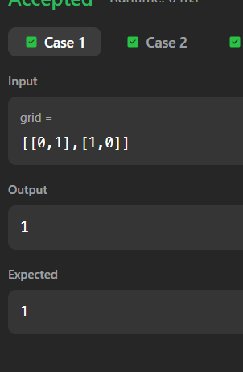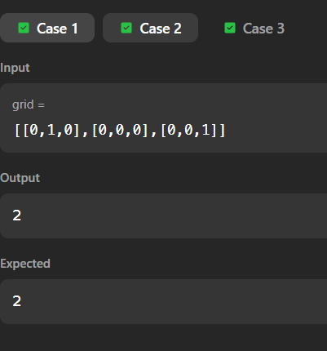

Write program to obtain the Topological ordering of vertices in a given digraph.

Code:
#include <stdio.h> #define MAX 10
int graph[MAX][MAX], visited[MAX], stack[MAX]; int n, top = -1;
void dfs(int v)
{
visited[v] = 1;
for(int i = 0; i < n; i++)
{
if(graph[v][i] && !visited[i]) dfs(i);
}
stack[++top] = v;
}
int main()
{
printf("Enter number of vertices: "); scanf("%d", &n);
printf("Enter adjacency matrix:\n"); for(int i = 0; i < n; i++)
{
for(int j = 0; j < n; j++)
{
scanf("%d", &graph[i][j]);
}
}
for(int i = 0; i < n; i++)
{

visited[i] = 0;
}
for(int i = 0; i < n; i++)
{
if(!visited[i]) dfs(i);
}
printf("Topological Ordering:\n"); while(top != -1)
{
printf("%d ", stack[top--]);
}
return 0;
}

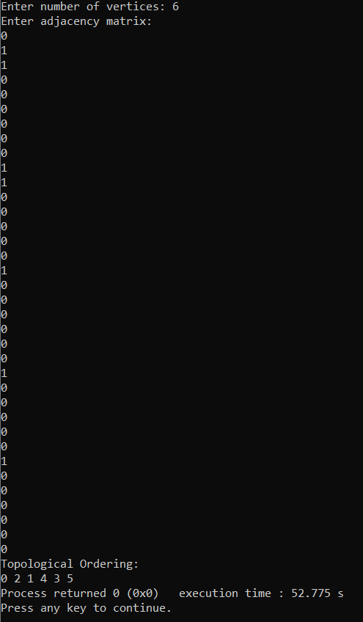

Implement Johnson Trotter algorithm to generate permutations.

Code:
#include <stdio.h>
int mobile(int a[], int dir[], int n)
{
int mobile_prev = 0, mobile = 0; for(int i = 0; i < n; i++)
{
if(dir[a[i]-1] == 0 && i != 0)
{
if(a[i] > a[i-1] && a[i] > mobile_prev)
{
mobile = a[i]; mobile_prev = mobile;
}
}
if(dir[a[i]-1] == 1 && i != n-1)
{
if(a[i] > a[i+1] && a[i] > mobile_prev)
{
mobile = a[i]; mobile_prev = mobile;
}
}
}
return mobile;
}
int position(int a[], int n, int mobile)
{
for(int i = 0; i < n; i++)

{
if(a[i] == mobile) return i;
}
return 0;
}
void printPermutation(int a[], int n)
{
for(int i = 0; i < n; i++) printf("%d ", a[i]);
printf("\n");
}
int main()
{
int n;
printf("Enter value of n: "); scanf("%d", &n);
int a[n], dir[n];
for(int i = 0; i < n; i++)
{
a[i] = i + 1;
dir[i] = 0;
}
printPermutation(a, n); for(int i = 1; i < n; i++)
{
for(int j = 0; j < i; j++)
{
int mobile_num = mobile(a, dir, n); int pos = position(a, n, mobile_num);

if(dir[mobile_num-1] == 0)
{
int temp = a[pos]; a[pos] = a[pos-1]; a[pos-1] = temp;
}
else
{
int temp = a[pos]; a[pos] = a[pos+1]; a[pos+1] = temp;
}
for(int k = 0; k < n; k++)
{
if(a[k] > mobile_num) dir[a[k]-1] = !dir[a[k]-1];
}
printPermutation(a, n);
}
}
return 0;
}

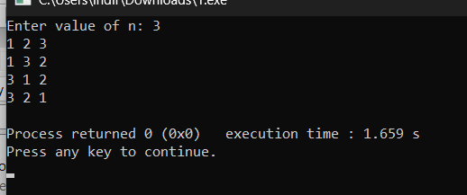

Sort a given set of N integer elements using Merge Sort technique and compute its time taken. Run the program for different values of N and record the time taken to sort.

Code:

#include <stdio.h> #include <time.h>
void merge(int a[], int low, int mid, int high)
{
int i = low, j = mid + 1, k = 0; int temp[1000];
while(i <= mid && j <= high)
{
if(a[i] < a[j]) temp[k++] = a[i++];
else
temp[k++] = a[j++];
}
while(i <= mid) temp[k++] = a[i++];
while(j <= high) temp[k++] = a[j++];
for(i = low, k = 0; i <= high; i++, k++) a[i] = temp[k];
}
void mergeSort(int a[], int low, int high)
{
if(low < high)
{
int mid = (low + high) / 2;

mergeSort(a, low, mid); mergeSort(a, mid + 1, high); merge(a, low, mid, high);
}
}
int main()
{
int n, a[1000];
printf("Enter number of elements: "); scanf("%d", &n);
printf("Enter elements:\n"); for(int i = 0; i < n; i++)
scanf("%d", &a[i]); clock_t start = clock(); mergeSort(a, 0, n - 1); clock_t end = clock(); printf("Sorted array:\n"); for(int i = 0; i < n; i++)
printf("%d ", a[i]);
double time_taken = (double)(end - start) / CLOCKS_PER_SEC; printf("\nTime taken = %f seconds\n", time_taken);
return 0;
}

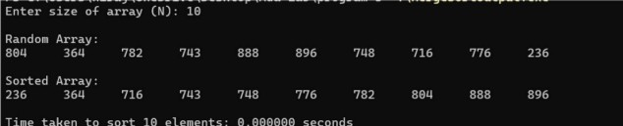

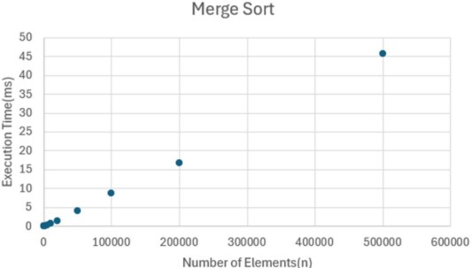

Sort a given set of N integer elements using Quick Sort technique and compute its time taken.

Code:
#include <stdio.h> #include <time.h>
int partition(int a[], int low, int high)
{
int pivot = a[low]; int i = low + 1; int j = high;
int temp; while(1)
{
while(i <= high && a[i] <= pivot) i++;
while(a[j] > pivot) j--;
if(i < j)
{
temp = a[i]; a[i] = a[j]; a[j] = temp;
}
else
break;
}
temp = a[low]; a[low] = a[j]; a[j] = temp; return j;
}

void quickSort(int a[], int low, int high)
{
if(low < high)
{
int j = partition(a, low, high); quickSort(a, low, j - 1); quickSort(a, j + 1, high);
}
}
int main()
{
int n, a[1000];
printf("Enter number of elements: "); scanf("%d", &n);
for(int i = 0; i < n; i++) scanf("%d", &a[i]); clock_t start = clock();
quickSort(a, 0, n - 1); clock_t end = clock(); printf("Sorted array:\n"); for(int i = 0; i < n; i++)
printf("%d ", a[i]);
double time_taken = (double)(end - start) / CLOCKS_PER_SEC; printf("\nTime taken = %f seconds\n", time_taken);
return 0;
}

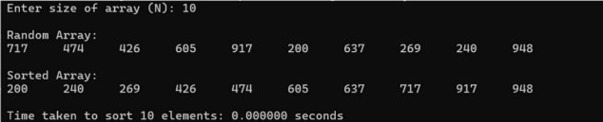

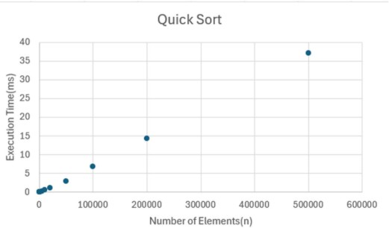

Sort a given set of N integer elements using Heap Sort technique and compute its time taken.

Code:
#include <stdio.h> #include <time.h>
void heapify(int a[], int n, int i)
{
int largest = i;
int left = 2 * i + 1; int right = 2 * i + 2;
if(left < n && a[left] > a[largest]) largest = left;
if(right < n && a[right] > a[largest]) largest = right;
if(largest != i)
{
int temp = a[i]; a[i] = a[largest]; a[largest] = temp;
heapify(a, n, largest);
}
}
void heapSort(int a[], int n)
{
for(int i = n / 2 - 1; i >= 0; i--) heapify(a, n, i);
for(int i = n - 1; i >= 0; i--)
{
int temp = a[0]; a[0] = a[i];
a[i] = temp;

heapify(a, i, 0);
}
}
int main()
{
int n, a[100];
printf("Enter number of elements: "); scanf("%d", &n);
printf("Enter elements:\n"); for(int i = 0; i < n; i++)
scanf("%d", &a[i]); clock_t start = clock(); heapSort(a, n); clock_t end = clock();
printf("Sorted array:\n"); for(int i = 0; i < n; i++)
printf("%d ", a[i]);
double time_taken = (double)(end - start) / CLOCKS_PER_SEC; printf("\nTime taken = %f seconds\n", time_taken);
return 0;
}

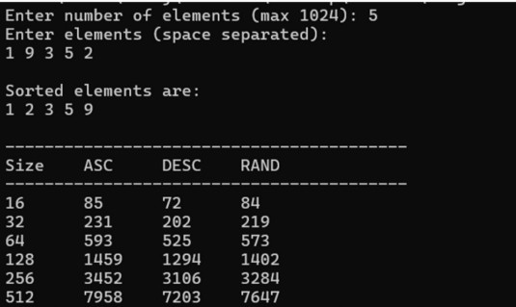

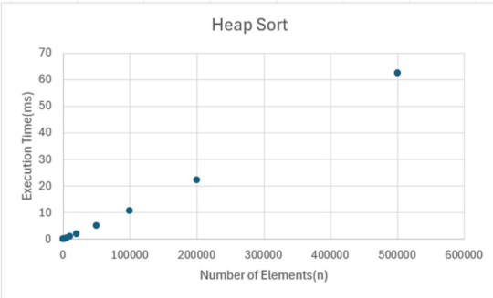

Implement 0/1 Knapsack problem using dynamic programming.

Code:

#include <stdio.h> int max(int a, int b)
{
return (a > b) ? a : b;
}
int main()
{
int n, m;
printf("Enter number of items: "); scanf("%d", &n);
int profit[n], weight[n]; printf("Enter profits:\n"); for(int i = 0; i < n; i++)
scanf("%d", &profit[i]); printf("Enter weights:\n"); for(int i = 0; i < n; i++)
scanf("%d", &weight[i]); printf("Enter capacity: "); scanf("%d", &m);
int k[n + 1][m + 1]; for(int i = 0; i <= n; i++)
{
for(int w = 0; w <= m; w++)
{
if(i == 0 || w == 0) k[i][w] = 0;

else if(weight[i - 1] <= w)
k[i][w] = max(profit[i - 1] + k[i - 1][w - weight[i - 1]], k[i - 1][w]);
else
k[i][w] = k[i - 1][w];
}
}
printf("Maximum profit = %d\n", k[n][m]); return 0;
}

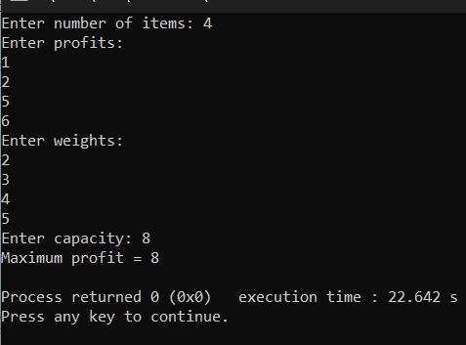

Implement All Pair Shortest paths problem using Floyd’s algorithm.

Code:
#include <stdio.h> #define INF 999 int main()
{
int n;
printf("Enter number of vertices: "); scanf("%d", &n);
int a[n][n];
printf("Enter cost matrix:\n"); for(int i = 0; i < n; i++)
{
for(int j = 0; j < n; j++)
{
scanf("%d", &a[i][j]);
}
}
for(int k = 0; k < n; k++)
{
for(int i = 0; i < n; i++)
{
for(int j = 0; j < n; j++)
{
if(a[i][k] + a[k][j] < a[i][j])
a[i][j] = a[i][k] + a[k][j];
}
}
}

printf("Shortest path matrix:\n"); for(int i = 0; i < n; i++)
{
for(int j = 0; j < n; j++)
{
printf("%d ", a[i][j]);
}
printf("\n");
}
return 0;
}

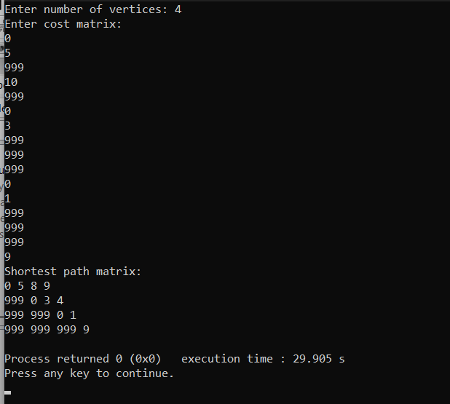

(a) Find Minimum Cost Spanning Tree of a given undirected graph using Prim’s algorithm.

Code:

#include <stdio.h> #define INF 999 int main()
{
int n;
printf("Enter number of vertices: "); scanf("%d", &n);
int cost[n][n];
printf("Enter cost matrix:\n"); for(int i = 0; i < n; i++)
{
for(int j = 0; j < n; j++)
{
scanf("%d", &cost[i][j]);

if(cost[i][j] == 0)
cost[i][j] = INF;
}
}
int visited[n];
for(int i = 0; i < n; i++) visited[i] = 0;
visited[0] = 1;
int edges = 0, mincost = 0; while(edges < n - 1)
{
int min = INF, a = -1, b = -1;

for(int i = 0; i < n; i++)
{

if(visited[i])
{
for(int j = 0; j < n; j++)
{
if(!visited[j] && cost[i][j] < min)
{
min = cost[i][j];
a = i;
b = j;
}
}
}
}
printf("%d -> %d = %d\n", a, b, min); mincost += min;
visited[b] = 1; edges++;
}
printf("Minimum cost = %d\n", mincost); return 0;
}

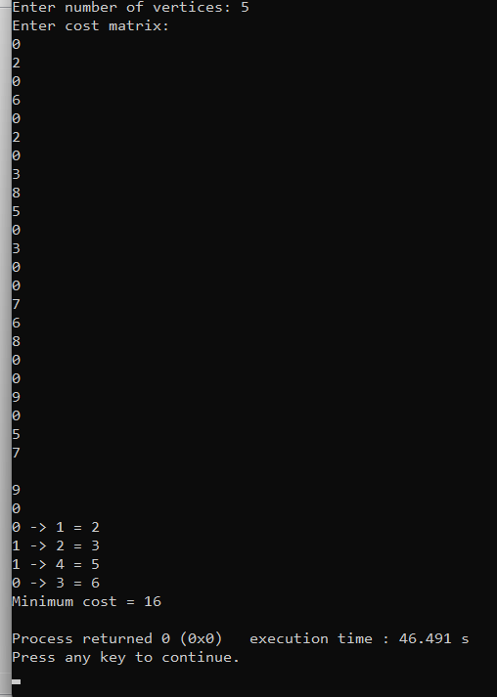

8(b). Find Minimum Cost Spanning Tree of a given undirected graph using Kruskal’s algorithm.

Code:

#include <stdio.h> #define MAX 20
#define INF 999 int parent[MAX]; int find(int i)
{
while(parent[i]) i = parent[i];
return i;
}
int uni(int i, int j)
{
if(i != j)
{
parent[j] = i; return 1;
}
return 0;
}
int main()
{
int n;
printf("Enter number of vertices: "); scanf("%d", &n);
int cost[MAX][MAX]; printf("Enter cost matrix:\n"); for(int i = 0; i < n; i++)
{
for(int j = 0; j < n; j++)

{
scanf("%d", &cost[i][j]); if(cost[i][j] == 0)
cost[i][j] = INF;
}
}
int edges = 0, mincost = 0; while(edges < n - 1)
{
int min = INF, a = -1, b = -1;

for(int i = 0; i < n; i++)
{
for(int j = 0; j < n; j++)
{
if(cost[i][j] < min)
{
min = cost[i][j];
a = i;
b = j;
}
}
}
int u = find(a); int v = find(b); if(uni(u, v))
{
printf("%d -> %d = %d\n", a, b, min);

mincost += min; edges++;
}
cost[a][b] = cost[b][a] = INF;
}

printf("Minimum cost = %d\n", mincost); return 0;
}

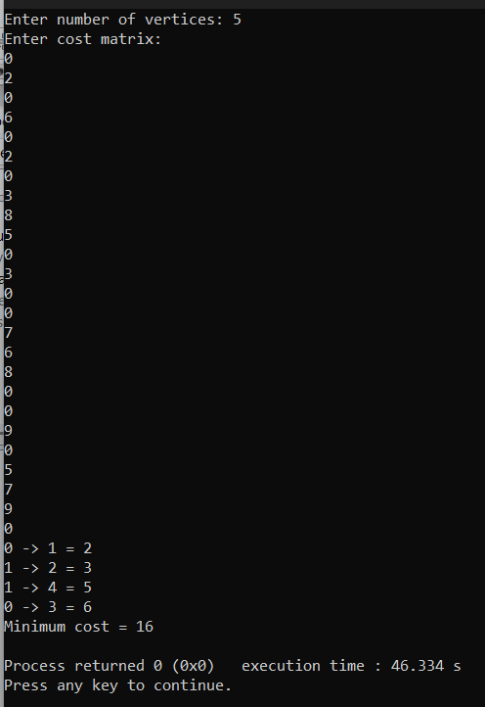

Implement Fractional Knapsack using Greedy technique.

Code:

#include <stdio.h> struct Item
{
int profit, weight; float ratio;
};
int main()
{
int n;
float capacity, totalProfit = 0; printf("Enter number of items: "); scanf("%d", &n);
struct Item item[n]; for(int i = 0; i < n; i++)
{
printf("Enter profit and weight of item %d: ", i + 1); scanf("%d%d", &item[i].profit, &item[i].weight); item[i].ratio = (float)item[i].profit / item[i].weight;
}
printf("Enter capacity of knapsack: "); scanf("%f", &capacity);
for(int i = 0; i < n - 1; i++)
{
for(int j = i + 1; j < n; j++)
{
if(item[i].ratio < item[j].ratio)
{
struct Item temp = item[i]; item[i] = item[j];
item[j] = temp;

}
}
}
for(int i = 0; i < n; i++)
{
if(capacity >= item[i].weight)
{
capacity -= item[i].weight; totalProfit += item[i].profit;
}
else
{
totalProfit += item[i].ratio * capacity; break;
}
}
printf("Maximum profit = %.2f\n", totalProfit); return 0;
}

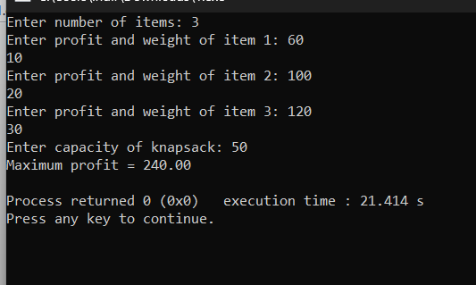

From a given vertex in a weighted connected graph, find shortest paths to other vertices using Dijkstra’s algorithm.

Code:

#include <stdio.h> #define INF 999 int main()
{
int n;
printf("Enter number of vertices: "); scanf("%d", &n);
int cost[n][n];
printf("Enter cost matrix:\n"); for(int i = 0; i < n; i++)
{
for(int j = 0; j < n; j++)
{
scanf("%d", &cost[i][j]);

if(cost[i][j] == 0 && i != j)
cost[i][j] = INF;
}
}
int source;
printf("Enter source vertex: "); scanf("%d", &source);
int distance[n], visited[n]; for(int i = 0; i < n; i++)
{
distance[i] = cost[source][i]; visited[i] = 0;
}

distance[source] = 0;
visited[source] = 1;
for(int count = 1; count < n - 1; count++)
{
int min = INF, next = -1; for(int i = 0; i < n; i++)
{
if(!visited[i] && distance[i] < min)
{
min = distance[i]; next = i;
}
}
visited[next] = 1; for(int i = 0; i < n; i++)
{
if(!visited[i] &&
min + cost[next][i] < distance[i])
{
distance[i] = min + cost[next][i];
}
}
}
printf("Shortest distances from source vertex %d:\n", source); for(int i = 0; i < n; i++)
{
printf("%d -> %d = %d\n", source, i, distance[i]);
}
return 0;
}

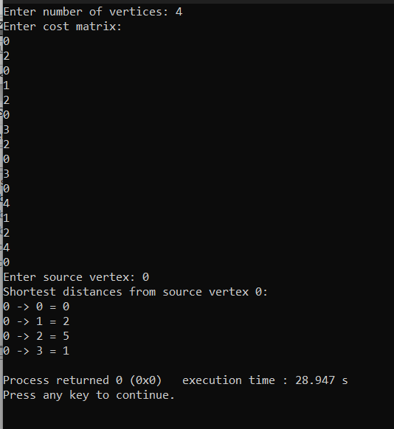

Implement “N-Queens Problem” using Backtracking.

Code:

#include <stdio.h> #include <stdlib.h> int x[20], count = 0; int place(int k, int i)
{
for(int j = 1; j < k; j++)
{
if(x[j] == i || abs(x[j] - i) == abs(j - k)) return 0;
}
return 1;
}
void nqueen(int k, int n)
{
for(int i = 1; i <= n; i++)
{
if(place(k, i))
{
x[k] = i;

if(k == n)
{
count++;
printf("\nSolution %d:\n", count); for(int j = 1; j <= n; j++)
{
for(int p = 1; p <= n; p++)
{
if(x[j] == p)
printf("Q ");

else
printf(". ");
}
printf("\n");
}
}
else
{
nqueen(k + 1, n);
}
}
}
}
int main()
{
int n;
printf("Enter number of queens: "); scanf("%d", &n);
nqueen(1, n); if(count == 0)
printf("No solution exists"); return 0;
}
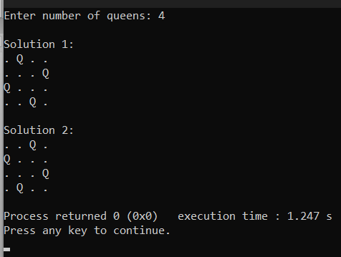

Coding challenge 1:
You are given an integer array nums. You are initially positioned at the array's first index, and each element in the array represents your maximum jump length at that position.

Return true if you can reach the last index, or false otherwise.

Example 1:
Input: nums = [2,3,1,1,4] Output: true
Explanation: Jump 1 step from index 0 to 1, then 3 steps to the last index. Example 2:
Input: nums = [3,2,1,0,4] Output: false
Explanation: You will always arrive at index 3 no matter what. Its maximum jump length is 0, which makes it impossible to reach the last index.

Constraints:
1 <= nums.length <= 104
0 <= nums[i] <= 105

.Solution:
bool canJump(int* nums, int numsSize) { int farthest = 0;
for (int i = 0; i < numsSize; i++) { if (i > farthest)
return false;
if (i + nums[i] > farthest) farthest = i + nums[i];

if (farthest >= numsSize - 1) return true;
}
return true;
}

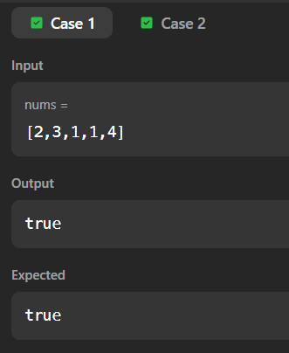
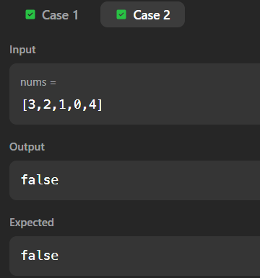

Coding challenge 2:

You are given an array of k linked-lists lists, each linked-list is sorted in ascending order. Merge all the linked-lists into one sorted linked-list and return it.

Example 1:
Input: lists = [[1,4,5],[1,3,4],[2,6]] Output: [1,1,2,3,4,4,5,6]
Explanation: The linked-lists are: [
1->4->5,
1->3->4,
2->6
]
merging them into one sorted linked list: 1->1->2->3->4->4->5->6
Example 2:

Input: lists = [] Output: [] Example 3:

Input: lists = [[]] Output: []

Constraints:

k == lists.length 0 <= k <= 104

0 <= lists[i].length <= 500
-104 <= lists[i][j] <= 104
lists[i] is sorted in ascending order.
The sum of lists[i].length will not exceed 104.

.Solution:

struct ListNode* mergeTwoLists(struct ListNode* l1, struct ListNode* l2) { struct ListNode dummy;
struct ListNode *tail = &dummy; dummy.next = NULL;
while (l1 && l2) {
if (l1->val <= l2->val) { tail->next = l1;
l1 = l1->next;
} else {
tail->next = l2; l2 = l2->next;
}
tail = tail->next;
}
if (l1)
tail->next = l1; else
tail->next = l2; return dummy.next;
}

struct ListNode* mergeKLists(struct ListNode** lists, int listsSize) { if (listsSize == 0)
return NULL; int interval = 1;
while (interval < listsSize) {
for (int i = 0; i + interval < listsSize; i += interval * 2) { lists[i] = mergeTwoLists(lists[i], lists[i + interval]);
}
interval *= 2;
}
return lists[0];
}

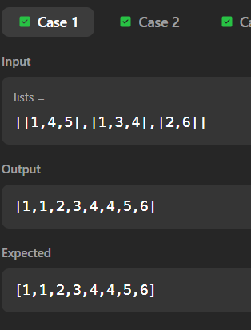
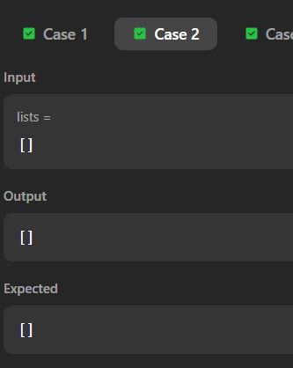

Coding challenge 3:

Given an integer array nums and an integer k, return the kth largest element in the array. Note that it is the kth largest element in the sorted order, not the kth distinct element.
Can you solve it without sorting?

Example 1:
Input: nums = [3,2,1,5,6,4], k = 2 Output: 5
Example 2:
Input: nums = [3,2,3,1,2,4,5,5,6], k = 4
Output: 4

Constraints:
1 <= k <= nums.length <= 105
-104 <= nums[i] <= 104

.Solution:
int partition(int* nums, int left, int right) { int pivot = nums[right];
int i = left;
for (int j = left; j < right; j++) {
if (nums[j] > pivot) { // Descending order int temp = nums[i];
nums[i] = nums[j]; nums[j] = temp;
i++;
}
}

int temp = nums[i]; nums[i] = nums[right]; nums[right] = temp;
return i;
}
int quickSelect(int* nums, int left, int right, int k) { int pivotIndex = partition(nums, left, right);
if (pivotIndex == k - 1) return nums[pivotIndex];
else if (pivotIndex > k - 1)
return quickSelect(nums, left, pivotIndex - 1, k); else
return quickSelect(nums, pivotIndex + 1, right, k);
}
int findKthLargest(int* nums, int numsSize, int k) { return quickSelect(nums, 0, numsSize - 1, k);
}
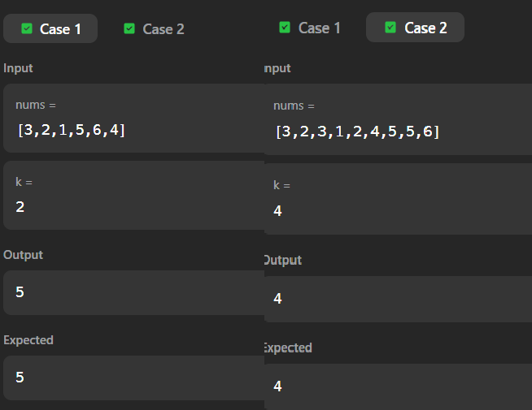

Coding challenge 4:
You are given an n x n binary matrix grid where 1 represents land and 0 represents water.
An island is a 4-directionally connected group of 1's not connected to any other 1's. There are exactly two islands in grid.
You may change 0's to 1's to connect the two islands to form one island. Return the smallest number of 0's you must flip to connect the two islands.

Example 1:
Input: grid = [[0,1],[1,0]] Output: 1
Example 2:
Input: grid = [[0,1,0],[0,0,0],[0,0,1]]
Output: 2
Example 3:
Input: grid = [[1,1,1,1,1],[1,0,0,0,1],[1,0,1,0,1],[1,0,0,0,1],[1,1,1,1,1]]
Output: 1

Constraints:
n == grid.length == grid[i].length 2 <= n <= 100
grid[i][j] is either 0 or 1.
There are exactly two islands in grid.

.Solution:
#define MAX 10000 int queue[MAX][2]; int front, rear;
void dfs(int** grid, int n, int r, int c) {
if (r < 0 || c < 0 || r >= n || c >= n || grid[r][c] != 1)

return;
grid[r][c] = 2; // mark first island queue[rear][0] = r;
queue[rear][1] = c; rear++;
dfs(grid, n, r + 1, c);
dfs(grid, n, r - 1, c);
dfs(grid, n, r, c + 1);
dfs(grid, n, r, c - 1);
}
int shortestBridge(int** grid, int gridSize, int* gridColSize) { int n = gridSize;
front = rear = 0; int found = 0;
// Find first island and mark it
for (int i = 0; i < n && !found; i++) { for (int j = 0; j < n && !found; j++) {
if (grid[i][j] == 1) {
dfs(grid, n, i, j);
found = 1;
}
}
}
int dirs[4][2] = {{1,0},{-1,0},{0,1},{0,-1}};
int steps = 0;
// BFS expansion while (front < rear) {
int size = rear - front;

while (size--) {
int r = queue[front][0]; int c = queue[front][1]; front++;
for (int k = 0; k < 4; k++) { int nr = r + dirs[k][0]; int nc = c + dirs[k][1];
if (nr < 0 || nc < 0 || nr >= n || nc >= n) continue;
if (grid[nr][nc] == 1)
return steps; // reached second island

if (grid[nr][nc] == 0) {
grid[nr][nc] = 2;
queue[rear][0] = nr; queue[rear][1] = nc; rear++;
}
}
}
steps++;
}
return -1;
}



Coding challenge 5:

You are given an array of binary strings strs and two integers m and n.

Return the size of the largest subset of strs such that there are at most m 0's and n 1's in the subset.

A set x is a subset of a set y if all elements of x are also elements of y.

Example 1:

Input: strs = ["10","0001","111001","1","0"], m = 5, n = 3
Output: 4
Explanation: The largest subset with at most 5 0's and 3 1's is {"10", "0001", "1", "0"}, so the answer is 4.
Other valid but smaller subsets include {"0001", "1"} and {"10", "1", "0"}.
{"111001"} is an invalid subset because it contains 4 1's, greater than the maximum of 3. Example 2:

Input: strs = ["10","0","1"], m = 1, n = 1 Output: 2
Explanation: The largest subset is {"0", "1"}, so the answer is 2.

Constraints:

1 <= strs.length <= 600

1 <= strs[i].length <= 100
strs[i] consists only of digits '0' and '1'. 1 <= m, n <= 100

.Solution:
int findMaxForm(char** strs, int strsSize, int m, int n) { int dp[101][101] = {0};

for (int i = 0; i < strsSize; i++) { int zeros = 0, ones = 0;

for (int j = 0; strs[i][j] != '\0'; j++) { if (strs[i][j] == '0')
zeros++; else
ones++;
}

for (int z = m; z >= zeros; z--) { for (int o = n; o >= ones; o--) {
if (dp[z - zeros][o - ones] + 1 > dp[z][o])
dp[z][o] = dp[z - zeros][o - ones] + 1;
}
}
}

return dp[m][n];

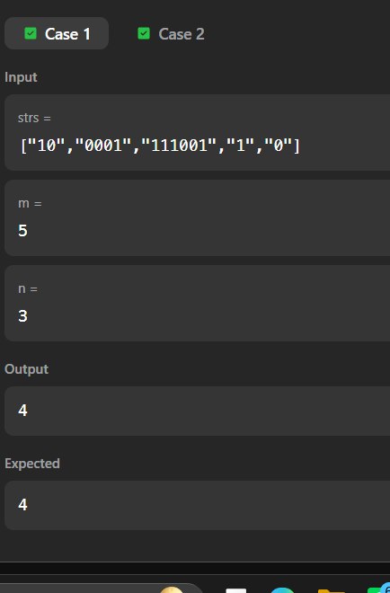
}

MISSING NUMBERS
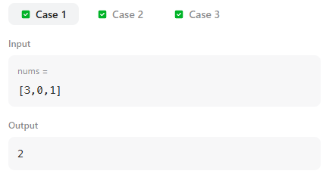

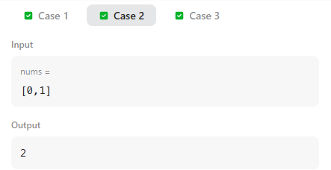
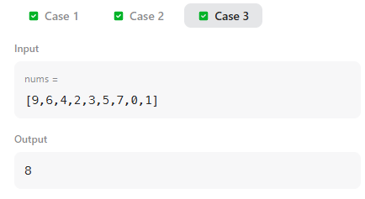

NUMBER OF ISLANDS[DFS]
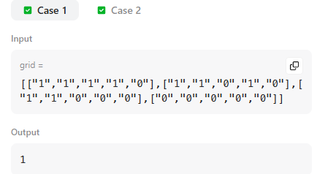
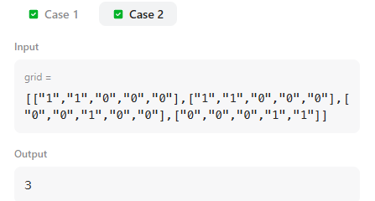

NUMBER OF PROVINCES
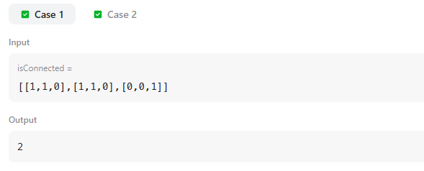
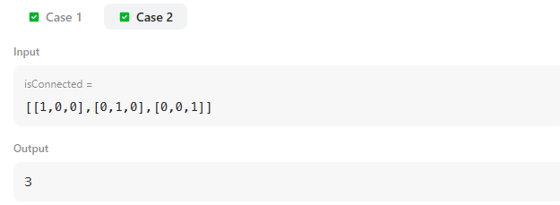
Maximum depth of Binary tree
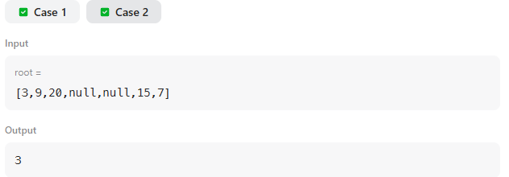
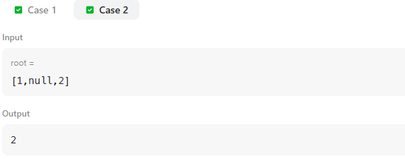
COURSE SCHEDULE II
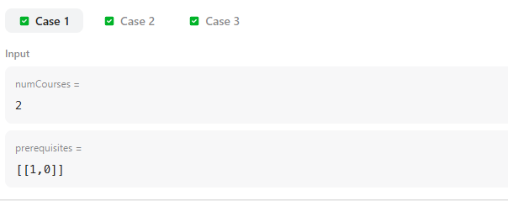
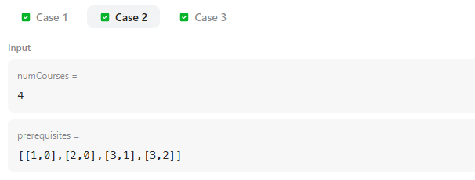
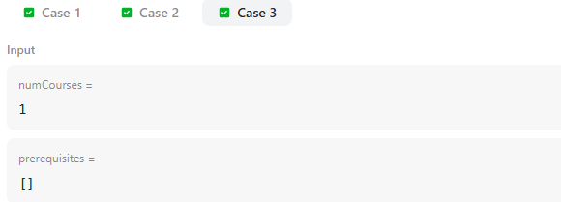
PARTITION EQUAL SUBSET SUM
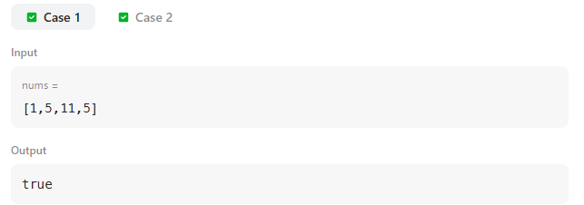
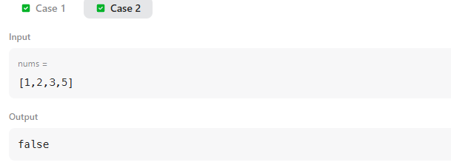

FIND THE CITY WITH THE SMALLEST NUMBER OF NEIGHBORS
